EXPERIMENT – 06

PROPERTY BUYING & RENTAL PROCESS (CHENNAI CITY)

Aim
To design and deploy a Property Buying & Rental Process application using Zoho Creator to demonstrate Software as a Service (SaaS), where users can manage property buying and rental details online.

Procedure
- Step 1: Login to Zoho Creator using your Zoho account.
- Step 2: Create a new application named 'Property Buying & Rental Process'.
- Step 3: Create a form with fields: Property For (Buy/Rent), Commercial/Residential, Rental Agreement, Area, Place, Range, Property Value, Bedrooms, Bathrooms and Availability.
- Step 4: Create workflows to categorize property value range and rental details.
- Step 5: Create reports to display all listed properties.

Fields Used
Field Name | Field Type | Description
Property For | Choice | Buy / Rent
Property Type | Choice | Residential / Commercial
Rental Agreement | Choice | Agreement Type
Area | Number | Area in Sq.ft
Place | Text | Location in Chennai
Range | Text | Budget Range
Property Value | Currency | Property Price
Availability | Choice | Available / Sold / Rented

Application Screens

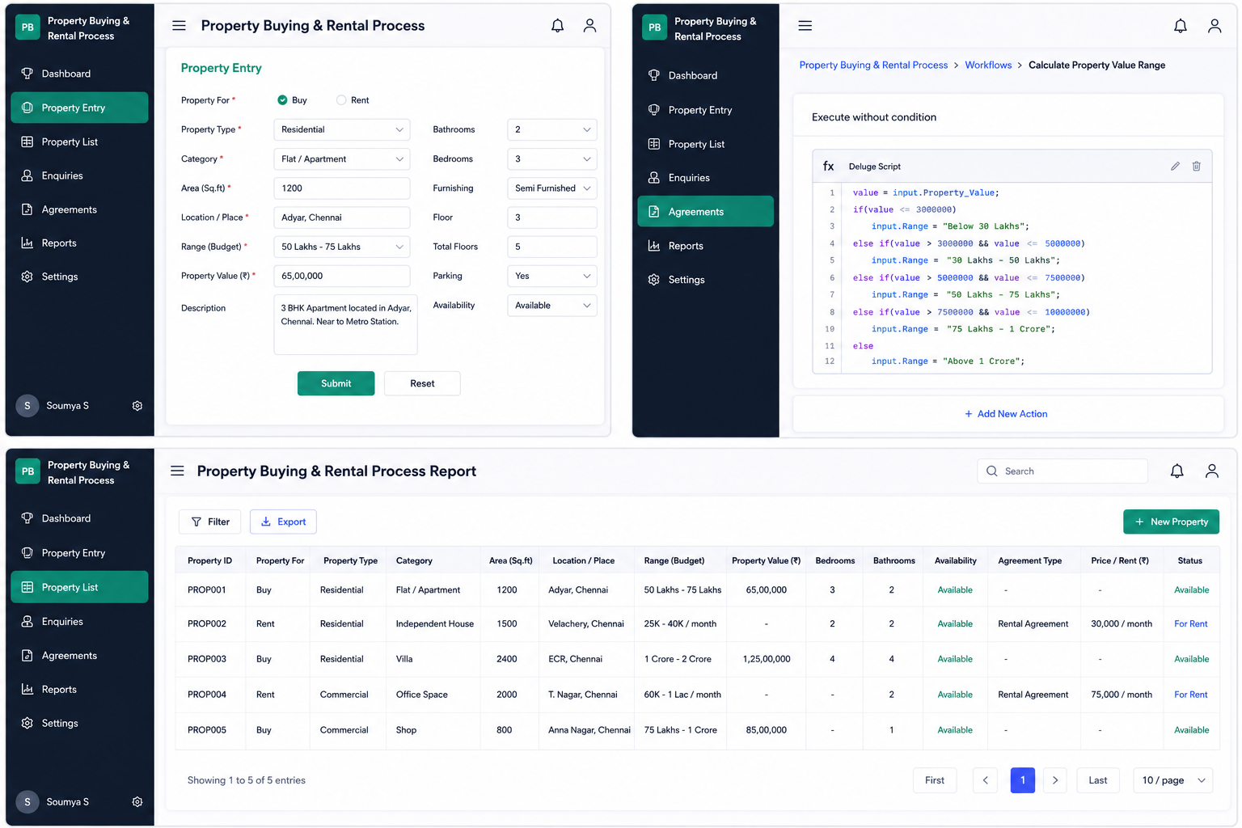
Figure 1: Property Buying & Rental Process Application





Result
A Property Buying & Rental Process SaaS application was successfully designed using Zoho Creator. The system manages property listings for buying and renting, stores property details, and generates online reports through the cloud.

